

**Database support in Microsoft Azure**

**Virtualization and Cloud Computing**



**May 4, 2020**

**Submitted BY: M. Iftikhar Uddin Khan Sami**

**022-16-113275**

Contents

Assignment- Database support in Microsoft Azure 1

Azure SQL Database 1

Deployment models 2

Purchasing models 2

Service tiers 3

Scalable performance and pools 3

Azure Monitoring Capabilities 3

Consistency levels and latency 4

Azure Advanced Data Security: 4

App and Business Running: 4

Secure your data: 4

References 4

# Assignment- Database support in Microsoft Azure

Azure database services are fully managed, freeing up valuable time you’d otherwise spend managing your database so you can focus on new ways to delight your users and unlock opportunities. Enterprise-grade performance with built-in high availability means you can scale quickly and reach global distribution without worrying about costly downtime. And developers can take advantage of industry-leading innovations such as built-in security with automatic monitoring and threat detection, automatic tuning for improved performance, and turnkey global distribution. On top of all of this, your investment is protected by financially backed SLAs.

## Azure SQL Database

Azure SQL Database is a fully managed Platform as a Service (PaaS) Database Engine that handles most of the database management functions such as upgrading, patching, backups, and monitoring without user involvement.

Azure SQL Database is always running on the latest stable version of SQL Server Database Engine and patched OS with 99.99% availability. PaaS capabilities that are built into Azure SQL database enables you to focus on the domain-specific database administration and optimization activities that are critical for your business.

## Deployment models

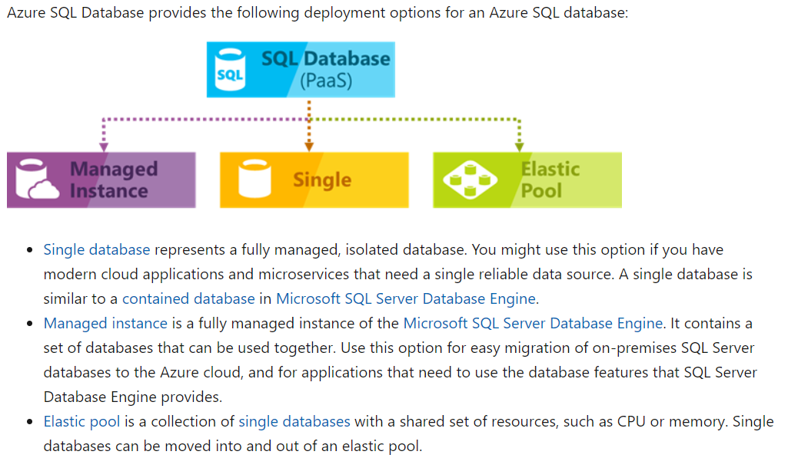

## Purchasing models

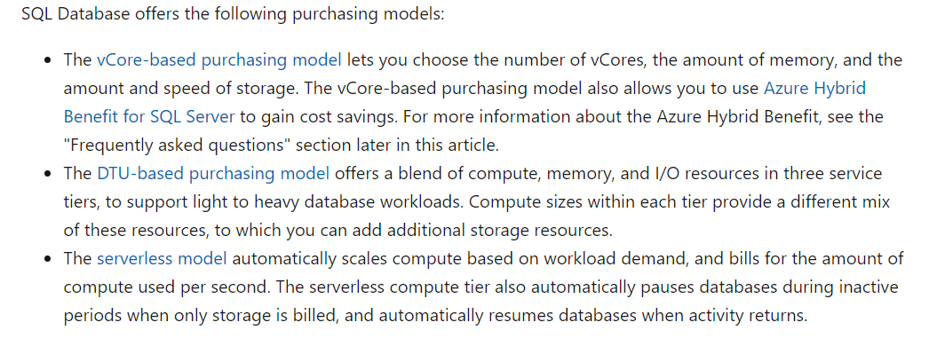

## Service tiers

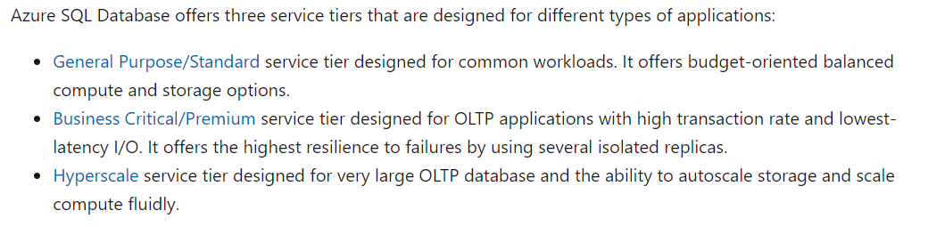

## Scalable performance and pools

You can define the amount of resources assigned.

* *With single databases*, each database is isolated from others and is portable. Each has its own guaranteed amount of compute, memory, and storage resources. The amount of the resources assigned to the database is dedicated to that database, and isn't shared with other databases in Azure. You can dynamically scale single database resources up and down. The single database option provides different compute, memory, and storage resources for different needs. For example, you can get 1 to 80 vCores, or 32 GB to 4 TB. The hyperscale service tier for single database enables you to scale to 100 TB, with fast backup and restore capabilities.
* *With elastic pools*, you can assign resources that are shared by all databases in the pool. You can create a new database, or move the existing single databases into a resource pool to maximize the use of resources and save money. This option also gives you the ability to dynamically scale elastic pool resources up and down.
* *With managed instances*, each managed instance is isolated from other instances with guaranteed resources. Within a managed instance, the instance databases share a set of resources. You can dynamically scale managed instance resources up and down.

## Azure Monitoring Capabilities

Azure provides built-in performance monitoring and alerting tools, combined with performance ratings, that enable you to monitor the status of thousands of databases. Using these tools, you can quickly assess the impact of scaling up or down, based on your current or projected performance needs. Additionally, SQL Database can emit metrics and resource logs for easier monitoring. You can configure SQL Database to store resource usage, workers and sessions, and connectivity into one of these Azure resources:

* ***Azure Storage***: For archiving vast amounts of telemetry for a small price.
* ***Azure Event Hubs***: For integrating SQL Database telemetry with your custom monitoring solution or hot pipelines.
* ***Azure Monitor logs***: For a built-in monitoring solution with reporting, alerting, and mitigating capabilities.

## Consistency levels and latency

The read latency for all consistency levels is always guaranteed to be less than 10 milliseconds at the 99th percentile. This read latency is backed by the SLA. The average read latency, at the 50th percentile, is typically 4 milliseconds or less.

## Azure Advanced Data Security:

1. Protect your databases from malicious acts with fine-grained access controls, Always Encrypted technology, and advanced threat protection capabilities.
2. Discover, track and remediate potential vulnerabilities from a single screen.
3. Azure SQL Database meets the most stringent compliance standards with built-in auditing and information protection technology.
4. Get continuous protection with deeper insights from Azure Security Center.
5. Multi-layered security provided by Microsoft across physical datacenters, infrastructure, and operations.

## App and Business Running:

Azure's industry-leading 99.99% availability SLA is powered by a global network of Microsoft-managed datacenters. The network helps keep your app running 24/7. You benefit from the built-in security, fault tolerance, and data protection in Azure Database for MariaDB. With Azure Database for MariaDB, you can use point-in-time restore to recover a server to an earlier state, as far back as 35 days.

## Secure your data:

Azure database services have a tradition of data security that Azure Database for MariaDB upholds. Azure Database for MariaDB offers features that limit access, protect data at rest and in motion, and help you monitor activity.

## References

* <https://docs.microsoft.com/en-us/azure/sql-database/sql-database-technical-overview>